Assignment 0

Which of the following is NOT a social network?

 Facebook

 Koo

 Naukri

 LinkedIn

**Ans. Naukri**

StackOverflow and Quora belong to which class of online networks?

 Discussion forums and Community-based Question Answering

 Bookmarking and content curation networks

 Consumer review networks

 Blogging and publishing networks

**Ans. Discussion forums and community based question answering**

Which of the following is the verified twitter handle of Bengaluru City Police?

 @BlrCityPolice

 @blrcp

 @bangalore\_police

 @bengaluru\_police

**Ans. @BlrCityPolice**

Which of the following Twitter handle likely belongs to a bot account (i.e. likely a fake account)?

 @DelhiPolice

 @delhipolice1

 @hydcitypolice

 @Navimumpolice

**Ans. @delhipolice1**

Visit Dr. Ponnurangum Kumaraguru’s twitter profile ([https://twitter.com/ponguru](https://twitter.com/ponguru" \o "" \t "/Users/hamzakhan/Downloads/x/)). When did he join twitter?

 September 2009

 January 2010

 October 2009

 August 2009

**Ans. October 2009**

Trending is a feature of which of the following networks?

 Twitter

 Facebook

 Youtube

 All of the above

**Ans. All of the above**

Which of the following is a Facebook feature?

 Charity Donations

 Groups

 Pages

 All of the above

**Ans. All of the above**

Which of the following are anonymous networks?

 Whisper

 Blind

 4chan

 Indeed

**Ans. Whisper, Blind, 4Chan**

When a person blocks someone on Facebook, the other party gets a notification.

 True

 False

**Ans. False**

Orkut was owned by:

 Google

 Microsoft

 Amazon

 Uber

Ans. Google

Assignment 1

Which of the following is/are anonymous social networking sites ?

 Whisper

 Sarahah

 Facebook

 X (Formerly Twitter)

### Yes, the answer is correct. Score: 1

### Accepted Answers:

*Whisper*

*Sarahah*

**1 point**

Which of the following statements is/are true about ephemeral content on social networks ?

 Content on social networks disappears after a fixed period of time.

 Snaps on Snapchat are an example of ephemeral content.

 Stories on Instagram are an example of ephemeral content.

 None of the above.

### Yes, the answer is correct. Score: 1

### Accepted Answers:

*Content on social networks disappears after a fixed period of time.*

*Snaps on Snapchat are an example of ephemeral content.*

*Stories on Instagram are an example of ephemeral content.*

**1 point**

Which of the following 4 V’s of Social Media addresses the correctness of information posted online ?

 Velocity

 Veracity

 Volume

 Variety

### Yes, the answer is correct. Score: 1

### Accepted Answers:

*Veracity*

**1 point**

Facebook Friends and Instagram Followers follow the principles of a unidirectional network.

 True

 False

### No, the answer is incorrect. Score: 0

### Accepted Answers:

*False*

**1 point**

\_\_\_\_ helps users on social media to find posts related to a specific topic by clicking or searching.

 Mentions

 Hashtags

 Shares

 Likes

### Yes, the answer is correct. Score: 1

### Accepted Answers:

*Hashtags*

**1 point**

Degrees of Separation has reduced on Social Media due to:

 Facilitating Connections and Interactions across various locations

 Interconnected Networks

 Share Information and Communicate Globally

 None of the Above

### Partially Correct. Score: 0.33

### Accepted Answers:

*Facilitating Connections and Interactions across various locations*

*Interconnected Networks*

*Share Information and Communicate Globally*

**1 point**

Which of the following is the correct syntax for installing numpy version 1.21.5

 pip3 install numpy==1.21.5

 pip3 install package==numpy version==1.21.5

 pip3 install numpy --v=1.21.5

 None of the above

### Yes, the answer is correct. Score: 1

### Accepted Answers:

*pip3 install numpy==1.21.5*

**1 point**

Which of the following libraries can be used to send and receive requests to a server?

 numpy

 requests

 math

 None of the above

### Yes, the answer is correct. Score: 1

### Accepted Answers:

*requests*

**1 point**

A self-contained directory containing its own Python installation (for a particular version of Python) and libraries, allowing it to manage and isolate project dependencies.

 Python Standard Libraries

 PIP

 Virtual Environment

 None of the above

### Yes, the answer is correct. Score: 1

### Accepted Answers:

*Virtual Environment*

**1 point**

Which of the following are the advantages of a version control system ?

 Helps in keeping a record of all changes made to a file in its history.

 Allows for collaboration between various people working on the same project.

 Allows for backup and recovery in a project.

 None of the Above

### Yes, the answer is correct. Score: 1

### Accepted Answers:

*Helps in keeping a record of all changes made to a file in its history.*

*Allows for collaboration between various people working on the same project.*

*Allows for backup and recovery in a project.*

**1 point**

Social Media constitutes:

 Social Networks (Facebook, LinkedIn etc.)

 Virtual Worlds (Habbo, Club Penguin etc.)

 Livecasts (Twitch, Yahoo! Live etc.)

 Content Sharing Platforms (YouTube, Flickr etc.)

### Yes, the answer is correct. Score: 1

### Accepted Answers:

*Social Networks (Facebook, LinkedIn etc.)*

*Virtual Worlds (Habbo, Club Penguin etc.)*

*Livecasts (Twitch, Yahoo! Live etc.)*

*Content Sharing Platforms (YouTube, Flickr etc.)*

**1 point**

Which of the following platforms allow for managing/hosting git repositories ?

 GitHub

 GitLab

 Bitbucket

 All of the above

### Yes, the answer is correct. Score: 1

### Accepted Answers:

*All of the above*

**1 point**

Select the correct syntax for allowing git to track all files in a repository (assume you are in the root of the repository)

 git add --all

 git commit -m "track"

 git status

 git log

### Yes, the answer is correct. Score: 1

### Accepted Answers:

*git add --all*

**1 point**

Creating a new file in a git repository adds it to :

 Tracked Files

 Untracked Files

 Remote Repository

 None of the Above

### Yes, the answer is correct. Score: 1

### Accepted Answers:

*Untracked Files*

**1 point**

Select the correct syntax for pushing an existing repository to a remote repository on GitHub

 git push origin master

 git commit -m "Push to GitHub"

 git add remote origin

 git pull origin master

### No, the answer is incorrect. Score: 0

### Accepted Answers:

*git push origin master*

**1 point**

Which of the following is the correct syntax for installing a package Ubuntu computer ?

 sudo apt install <PACKAGE\_NAME>

 sudo apt-<PACKAGE\_NAME> install ubuntu

 sudo apt-install <PACKAGE\_NAME>

 sudo get <PACKAGE\_NAME>

### Yes, the answer is correct. Score: 1

### Accepted Answers:

*sudo apt install <PACKAGE\_NAME>*

Assignment 2

What does JSON stand for ?

 JavaScript Object Notation

 Java Standard Object Notation

 JSON Scripted Object Name

 Joint Syntax Object Network

### Yes, the answer is correct. Score: 1

### Accepted Answers:

*JavaScript Object Notation*

**1 point**

In which of the following formats does an API usually return its response ?

 JSON

 XML

 TSV

 None of the above

### Yes, the answer is correct. Score: 1

### Accepted Answers:

*JSON*

*XML*

**1 point**

MongoDB stores data in a structure most similar to \_\_\_\_.

 JSON

 SQL

 XML

 None of the above

### Yes, the answer is correct. Score: 1

### Accepted Answers:

*JSON*

**1 point**

MySQL can be used for querying relational databases.

 True

 False

### Yes, the answer is correct. Score: 1

### Accepted Answers:

*True*

**1 point**

Given a MongoDB collection named "words" with the following document structure:  
  
{  
"\_id":ObjectId("615243d88f0ae43f255874c1"),  
"count": 300,  
"department": "the"  
}  
  
Which MongoDB query would you use to retrieve all words with count in descending order ?

 db.words.find().sort({ count: -1 })

 db.words.find().sort({ count: 1 })

 db.words.find().order\_by("count", DESCENDING}

 db.words.find().sort({ descending: 1 })

### Yes, the answer is correct. Score: 1

### Accepted Answers:

*db.words.find().sort({ count: -1 })*

**1 point**

Which of the following are the components of a graph ?

 Vertices

 Edges

 Unique Identifier/ID

 All of the Above

### Yes, the answer is correct. Score: 1

### Accepted Answers:

*All of the Above*

**1 point**

Which of the following is true regarding the situation depicted in the graph below  
  
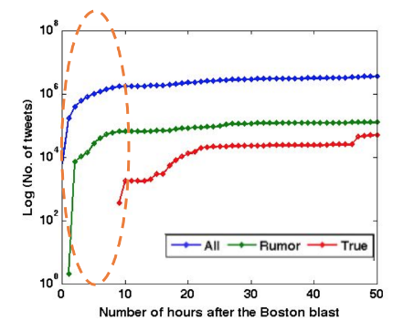

 False information/rumors spreads faster than facts/true information on social media

 True information spreads faster than false information/rumors on social media

 Cannot be Determined

### Yes, the answer is correct. Score: 1

### Accepted Answers:

*False information/rumors spreads faster than facts/true information on social media*

**1 point**

Select the correct sequence of steps taken towards evaluating social media data.

 Data Collection/Filtering > Data Characterization > Data Classification > Data Evaluation

 Data Collection/Filtering > Data Characterization > Data Evaluation > Data Classification

 Data Characterization > Data Collection/Filtering > Data Evaluation > Data Classification

 Data Characterization > Data Collection/Filtering > Data Classification > Data Evaluation

### Yes, the answer is correct. Score: 1

### Accepted Answers:

*Data Collection/Filtering > Data Characterization > Data Classification > Data Evaluation*

**1 point**

Which of the following attributes can be inferred from data collected via X (formerly Twitter) ?

 Number of Likes of the Tweet

 Number of times the Tweet has been viewed

 Unique identifier of the user/author of the Tweet

 None of the above

### Yes, the answer is correct. Score: 1

### Accepted Answers:

*Number of Likes of the Tweet*

*Number of times the Tweet has been viewed*

*Unique identifier of the user/author of the Tweet*

**1 point**

Which of the following processes can be used to receive annotated posts while determining their legitimacy ?

 A group of friends annotating posts given to them

 Crowd-sourcing / Mechanical Turk

 Getting Data from Fact Checking / News Outlets

 All of the above

### Yes, the answer is correct. Score: 1

### Accepted Answers:

*All of the above*

**1 point**

TweetCred is a chrome extension that ranks the credibility of each tweet on Twitter.

 True

 False

### Yes, the answer is correct. Score: 1

### Accepted Answers:

*True*

**1 point**

Which Python library would you most likely use to get the top 10 hot posts from the subreddit "r/politics" using the Reddit API?

 praw

 requests

 urllib

 json

### Yes, the answer is correct. Score: 1

### Accepted Answers:

*praw*

**1 point**

An indicator similar to hashtags is called \_\_\_\_\_\_ on Reddit.

 Flair

 Karma

 Comment

 Upvote

### Yes, the answer is correct. Score: 1

### Accepted Answers:

*Flair*

**1 point**

Communities on Reddit are called \_\_\_\_\_\_

 Subreddits

 Flairs

 Threads

 None of the above

### Yes, the answer is correct. Score: 1

### Accepted Answers:

*Subreddits*

**1 point**

A higher Follower-Friend ratio on Twitter can be associated with the popularity of the user

 True

 False

### Yes, the answer is correct. Score: 1

### Accepted Answers:

*True*

Assignment 3

Select the correct sequence of steps as used by Facebook Inspector (as Discussed in Lecture)  
  
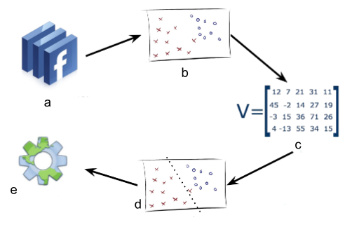

 Data Collection > Ground Truth Extraction > Feature Generation > Supervised Learning > Result via RESTful API

 Feature Generation > Data Collection > Supervised Learning > Ground Truth Extraction > Result via RESTful API

 Ground Truth Extraction > Data Collection > Supervised Learning > Feature Generation > Result via RESTful API

 Data Collection > Feature Generation > Ground Truth Extraction > Supervised Learning > Result via RESTful API

### Yes, the answer is correct. Score: 1

### Accepted Answers:

*Data Collection > Ground Truth Extraction > Feature Generation > Supervised Learning > Result via RESTful API*

**1 point**

Which of the following is/are correct statements in context of Web of Trust Score?

 Web of Trust score outputs the reputation of an input website

 Domain Age can be used as a feature for a Web of Trust score

 Domain Owner can be used a feature for a Web of Trust score

 None of the Above

### Yes, the answer is correct. Score: 1

### Accepted Answers:

*Web of Trust score outputs the reputation of an input website*

*Domain Age can be used as a feature for a Web of Trust score*

*Domain Owner can be used a feature for a Web of Trust score*

**1 point**

“Shantanu never likes people taking his photo because he doesn’t want it to be posted online”. According to Westin’s 3 Categories, Shantanu is a :

 Fundamentalist

 Pragmatist

 Unconcerned

 None of the above

### Yes, the answer is correct. Score: 1

### Accepted Answers:

*Fundamentalist*

**1 point**

"Geeta browses all social media websites on her laptop casually, but always opens her banking website in incognito for checking her balance” According to Westin’s 3 Categories, Geeta is a :

 Fundamentalist

 Pragmatist

 Unconcerned

 None of the above

### Yes, the answer is correct. Score: 1

### Accepted Answers:

*Pragmatist*

**1 point**

According to Westin’s 3 Categories, the lowest percentage of US citizens fall into the category of (as discussed in the lecture):

 Fundamentalist

 Pragmatist

 Unconcerned

### Yes, the answer is correct. Score: 1

### Accepted Answers:

*Unconcerned*

**1 point**

According to Westin’s 3 Categories, the highest percentage of US citizens fall into the category of (as discussed in the lecture) :

 Fundamentalist

 Pragmatist

 Unconcerned

### Yes, the answer is correct. Score: 1

### Accepted Answers:

*Pragmatist*

**1 point**

Which of the following can be used in authentication for the Twitter API ?

 Bearer Token

 Client ID

 Client Secret

 None of the above

### Partially Correct. Score: 0.33

### Accepted Answers:

*Bearer Token*

*Client ID*

*Client Secret*

**1 point**

Which of the following can be achieved using Twitter API ?

 Retrieving reverse chronological home timeline

 Retrieving user Tweet timeline

 Retrieving user mention timeline

 None of the above

### Yes, the answer is correct. Score: 1

### Accepted Answers:

*Retrieving reverse chronological home timeline*

*Retrieving user Tweet timeline*

*Retrieving user mention timeline*

**1 point**

Which of the following is the correct syntax for creating a tweets table with the specified attributes?  
  
tweet\_id : Primary Key, Not Null  
text: Not Null

CREATE TABLE tweets (

    tweet\_id VARCHAR(50) NOT NULL,

    text VARCHAR(500) NOT NULL,

    PRIMARY KEY (tweet\_id)

);

CREATE tweets TABLE (

    tweet\_id VARCHAR(50) NOT NULL,

    text VARCHAR(500) NOT NULL,

    PRIMARY KEY (tweet\_id)

);

CREATE TABLE (

    tweet\_id VARCHAR(50) NOT NULL,

    text VARCHAR(500) NOT NULL,

    PRIMARY KEY (tweet\_id),

    TABLE NAME(tweets)

);

CREATE TABLE tweets (

    tweet\_id VARCHAR(50),

    text VARCHAR(500),

    PRIMARY KEY (tweet\_id),

    NOT NULL (text)

);

### Yes, the answer is correct. Score: 1

### Accepted Answers:

*CREATE TABLE tweets (*

*tweet\_id VARCHAR(50) NOT NULL,*

*text VARCHAR(500) NOT NULL,*

*PRIMARY KEY (tweet\_id)*

*);*

**1 point**

Consider a table named “users” containing user profiles from Twitter, which of the following attributes can be used as a primary key in the table :

 Full Name of the User

 User ID of the User

 No. of Followers of the User

 No. of Tweets by the User

### Yes, the answer is correct. Score: 1

### Accepted Answers:

*User ID of the User*

Read through the report “Privacy in India: Attitudes and Awareness V 2.0” at [https://cdn.iiit.ac.in/cdn/precog.iiit.ac.in/research/privacyindia/PI\_2012\_Complete\_Report.pdf](https://cdn.iiit.ac.in/cdn/precog.iiit.ac.in/research/privacyindia/PI_2012_Complete_Report.pdf" \o "" \t "/Users/hamzakhan/Downloads/x/_blank) And answer the following questions **[11-12]** :

**1 point**

Which of the following method(s) were used for gathering information across India in the report above ?

 Surveys

 Focus Group Discussions

 Interviews

 None of the above

### No, the answer is incorrect. Score: 0

### Accepted Answers:

*Surveys*

*Focus Group Discussions*

*Interviews*

**1 point**

Which of the following methods resulted in the largest number of respondents across India ?

 Surveys

 Focus Group Discussions

 Interviews

 None of the above

### Yes, the answer is correct. Score: 1

### Accepted Answers:

*Surveys*

**1 point**

A table in SQL is called a \_\_\_\_\_\_ in MongoDB.

 Database

 Index

 Document

 Collection

### Yes, the answer is correct. Score: 1

### Accepted Answers:

*Collection*

**1 point**

A row in SQL is called a \_\_\_\_\_\_ in MongoDB.

 Collection

 Field

 Index

 Document

### Yes, the answer is correct. Score: 1

### Accepted Answers:

*Document*

**1 point**

Which of the following can be used to create a new database called “project” and create a collection named “users” inside it in MongoDB ?

 1. use project;  
2. db.users.insert({});

 1. use project;  
2. db.users.insert();

 1. create\_db project;  
2. db.users.insert({});

 1. create project;  
2. db.users.insert();

### Yes, the answer is correct. Score: 1

### Accepted Answers:

*1. use project;  
2. db.users.insert({});*

Assignment 4

What are the different forms of Privacy?

 Information

 Communication

 Territorial

 Bodily

### No, the answer is incorrect. Score: 0

### Accepted Answers:

*Information*

*Communication*

*Territorial*

*Bodily*

**1 point**

“Please Rob Me” highlighted issues specifically stemming from:

 Public Self-Disclosure of Information on Social Media by users

 Data leaks from social media websites due to hacking attempts

 Sharing passwords with your friends on Social Media

 None of the Above

### No, the answer is incorrect. Score: 0

### Accepted Answers:

*Public Self-Disclosure of Information on Social Media by users*

**1 point**

Using an unidentified source of information to extract an individual’s sensitive information is called :

 Re-identification

 Personally Identifiable Information

 Self-Disclosure

 None of the above

### No, the answer is incorrect. Score: 0

### Accepted Answers:

*Re-identification*

**1 point**

Considering each attribute in isolation, which of the following are examples of Personally Identifiable Information (PII):

 Race

 Age

 Aadhaar Number

 College Student ID

### No, the answer is incorrect. Score: 0

### Accepted Answers:

*Aadhaar Number*

*College Student ID*

**1 point**

What is the purpose of k-anonymity as discussed in the lecture?

 Protect PIIs of re-identified individuals

 Anonymise data without losing utility

 Make datasets larger for analysis

 None of the above

### No, the answer is incorrect. Score: 0

### Accepted Answers:

*Protect PIIs of re-identified individuals*

*Anonymise data without losing utility*

**1 point**

Latanya Sweeney’s experiments aimed to :

 Re-identify individuals from Match.com using their Facebook profiles

 Identification of individuals walking on a campus with data from Facebook

 Predict social security number from publicly available data

 Study behaviors of individuals aged 14-18 on Instagram

### No, the answer is incorrect. Score: 0

### Accepted Answers:

*Re-identify individuals from Match.com using their Facebook profiles*

*Identification of individuals walking on a campus with data from Facebook*

*Predict social security number from publicly available data*

**1 point**

What are the advantages of NumPy Arrays over Lists in Python?

 NumPy arrays are faster and more compact than Python lists.

 NumPy uses much less memory to store data and it provides a mechanism of specifying the data types.

 This allows the code to be optimized even further.

 None of the above.

### No, the answer is incorrect. Score: 0

### Accepted Answers:

*NumPy arrays are faster and more compact than Python lists.*

*NumPy uses much less memory to store data and it provides a mechanism of specifying the data types.*

*This allows the code to be optimized even further.*

**1 point**

Write Python code to convert the list [1,2,3,4] to a NumPy array.

import numpy as np

arr = np.array([1,2,3,4])

import numpy as np

arr = numpy.array([1,2,3,4])

import numpy as np

arr = np.array(1,2,3,4)

 All of the above

### No, the answer is incorrect. Score: 0

### Accepted Answers:

*import numpy as np*

*arr = np.array([1,2,3,4])*

**1 point**

What is the output of the following code:

*import numpy as np*

*a = np.array([range(i,i+3) for i in [1,2,3]])*

*print(a)*

[[1 2 3]

[2 3 4]

[3 4 5]]

[[1 2 3]

[1 2 3]

[1 2 3]]

[[1 2 3]

[4 5 6]

[7 8 9]]

 None of the above

### No, the answer is incorrect. Score: 0

### Accepted Answers:

*[[1 2 3]*

*[2 3 4]*

*[3 4 5]]*

**1 point**

Which of the following codes can be used to make a NumPy array of 10 random numbers?

import numpy as np

import random

l = []

for i in range(10):

    l.append(random.random())

zeros\_array = np.array(l)

print(zeros\_array)

import numpy as np

random\_array = np.random.rand(10)

import numpy as np

random\_array = np.random.random(10)

 None of the above

### No, the answer is incorrect. Score: 0

### Accepted Answers:

*import numpy as np*

*import random*

*l = []*

*for i in range(10):*

*l.append(random.random())*

*zeros\_array = np.array(l)*

*print(zeros\_array)*

*import numpy as np*

*random\_array = np.random.rand(10)*

*import numpy as np*

*random\_array = np.random.random(10)*

**1 point**

Which of the following NumPy functions can be used to generate an NxN diagonal matrix ?

 np.eye(5)

 np.diagonal(np.eye(5))

 np.diagonal(5)

 None of the above

### No, the answer is incorrect. Score: 0

### Accepted Answers:

*np.eye(5)*

**1 point**

Which of the following Python code can be used to read a CSV file using Pandas

import pandas as pd

data = pd.read\_excel('file.csv')

import pandas as pd

data = pandas.readcsv('file.csv')

import pandas as pd

data = pd.read\_csv('file.csv')

 None of the above.

### No, the answer is incorrect. Score: 0

### Accepted Answers:

*import pandas as pd*

*data = pd.read\_csv('file.csv')*

**1 point**

Consider the below structure of a dataframe.  
  
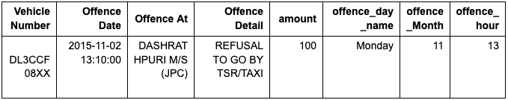  
Which of the following Python snippets can be used to plot a histogram of the amount column ?  
*Assume df is defined as the above dataframe with 100 rows.*

 df['amount'].plot.hist()

 df[df.columns[4]].plot.hist()

import matplotlib.pyplot as plt

plt.hist(df['amount'])

plt.xlabel('Amount')

plt.ylabel('Frequency')

plt.title('Histogram of Amount')

plt.show()

 None of the Above

### No, the answer is incorrect. Score: 0

### Accepted Answers:

*df['amount'].plot.hist()*

*df[df.columns[4]].plot.hist()*

*import matplotlib.pyplot as plt*

*plt.hist(df['amount'])*

*plt.xlabel('Amount')*

*plt.ylabel('Frequency')*

*plt.title('Histogram of Amount')*

*plt.show()*

**1 point**

What is the output of the following code ?

pd.Series(['A', 'B', 'C'], index=[1, 2, 3])

1    A

2    B

3    C

A    1

B    2

C    3

A    B

C    1

2    3

 None of the above

### No, the answer is incorrect. Score: 0

### Accepted Answers:

*1    A*

*2    B*

*3    C*

**1 point**

Select the correct option for plotting the below function using matplotlib  
  
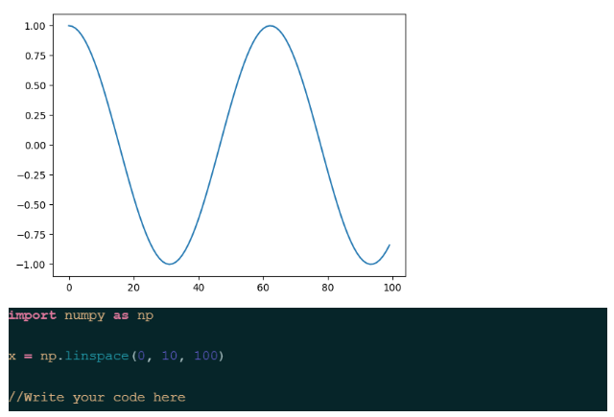

plt.plot(np.cos(x))

plt.show()

plt.scatter(x, np.sin(x))

plt.show()

plt.scatter(np.cos(x), x)

plt.show()

 None of the above

### No, the answer is incorrect. Score: 0

### Accepted Answers:

*plt.plot(np.cos(x))*

*plt.show()*

Assignment 5

What are the outcomes of publicizing police interactions on X (formerly Twitter) ?

 Appreciation of the Police by the Public

 Increased Trust in the Police

 Quick Resolutions of Public Grievances

 None of the above

### Yes, the answer is correct. Score: 1

### Accepted Answers:

*Appreciation of the Police by the Public*

*Increased Trust in the Police*

*Quick Resolutions of Public Grievances*

**1 point**

As discussed in the lectures, which of the following campaigns on social media to create trust in the police backfired ?

 #myNYPD

 #myLAPD

 #myDelhiPolice

 All of the above

### Yes, the answer is correct. Score: 1

### Accepted Answers:

*#myNYPD*

**1 point**

As of January 1, 2024 : Which of the following verification check marks are applied to Law Enforcement Accounts on X (formerly Twitter) ?

Blue Check Mark

Grey Check Mark

Gold Check Mark

 None of the above

### Yes, the answer is correct. Score: 1

### Accepted Answers:

*Grey Check Mark*

**1 point**

Which of the following attributes is the most effective in differentiating a real Police account from a fake Police account on X (formerly Twitter) as discussed in the lecture ?

 User Handle

 Profile Picture

 Verification Status of the Account

 None of the above

### Yes, the answer is correct. Score: 1

### Accepted Answers:

*Verification Status of the Account*

**1 point**

Analyzing data without any preconceptions is called \_\_\_\_\_

 Inductive Thematic Analysis

 Lexical Analysis

 Natural Language Processing

 None of the above

### Yes, the answer is correct. Score: 1

### Accepted Answers:

*Inductive Thematic Analysis*

**1 point**

Which of the following is/are true about the visualization shown below ?  
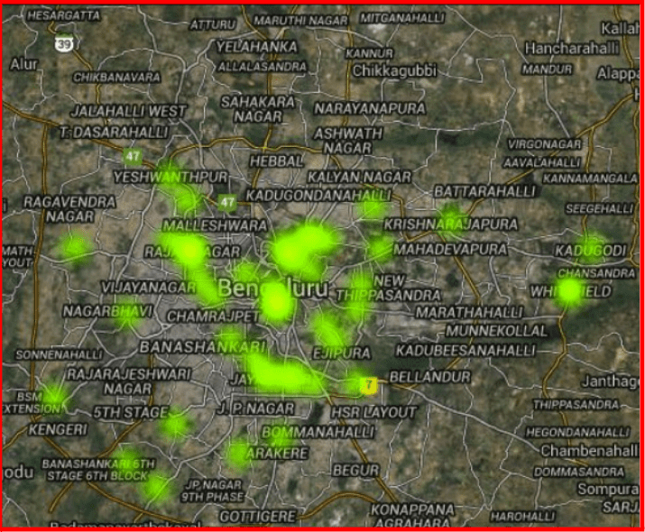

 The visualization is called a Heatmap

 The data used to plot the above visualization is called Temporal Data

 This type of visualization falls under the category of Geospatial Analysis

 None of the above

### Yes, the answer is correct. Score: 1

### Accepted Answers:

*The visualization is called a Heatmap*

*This type of visualization falls under the category of Geospatial Analysis*

**1 point**

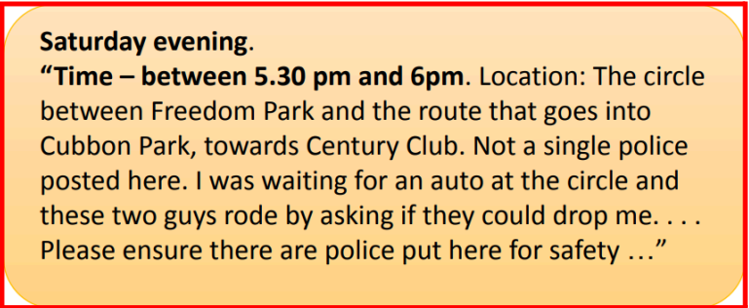   
  
What type of actionable information is highlighted in (bold) in the above example?

 Temporal data

 Spatial data

 Linguistic data

 None of the above

### Yes, the answer is correct. Score: 1

### Accepted Answers:

*Temporal data*

**1 point**

Consider the following tweet : “There is a huge pothole on the main road,Kindly repair it Address:- Opposite Kachieguda police station, Hyderabad”. This is an example of \_\_\_\_

 Actionable Information

 Unactionable Information

### Yes, the answer is correct. Score: 1

### Accepted Answers:

*Actionable Information*

**1 point**

As discussed in the lectures, communication of the police with the citizens on Social Media is \_\_\_\_\_\_

 Formal

 Informal

### No, the answer is incorrect. Score: 0

### Accepted Answers:

*Formal*

**1 point**

What is meant by an n-gram ?

 A sequence of n alternative characters in a text or speech corpus

 A method for optimizing databases using caching

 A continuous sequence of n items extracted from a text or speech corpus

 A method for optimizing big data queries using indexing

### Yes, the answer is correct. Score: 1

### Accepted Answers:

*A continuous sequence of n items extracted from a text or speech corpus*

**1 point**

All students taking the PSOSM course are divided into “groups” of students from each state of India. This can be best achieved using \_\_\_\_\_.

 n-gram

 k-means clustering

 LIWC

 None of the above

### Yes, the answer is correct. Score: 1

### Accepted Answers:

*k-means clustering*

**1 point**

As discussed in the lecture, which of the following measures of behaviors can be studied while analyzing communications between the police and citizens on social media.

 Topic Characteristics

 Engagement Measures

 Emotional Measures

 Social and Cognitive Measures

### Yes, the answer is correct. Score: 1

### Accepted Answers:

*Topic Characteristics*

*Engagement Measures*

*Emotional Measures*

*Social and Cognitive Measures*

**1 point**

LIWC can categorize an input corpus into the following categories:

 Positive Emotions

 Negative Emotions

 Anxiety

 Sadness

### Yes, the answer is correct. Score: 1

### Accepted Answers:

*Positive Emotions*

*Negative Emotions*

*Anxiety*

*Sadness*

**1 point**

Select the correct option(s) below while analyzing a post on social media:

 Valence refers to the negative or positive sentiment of the post

 Valence refers to the intensity of the sentiment expressed in the post

 Arousal refers to the negative or positive sentiment of the post

 Arousal refers to the intensity of the sentiment expressed in the post

### Yes, the answer is correct. Score: 1

### Accepted Answers:

*Valence refers to the negative or positive sentiment of the post*

*Arousal refers to the intensity of the sentiment expressed in the post*

**1 point**

Given below are two types of communication as discussed in the lecture.  
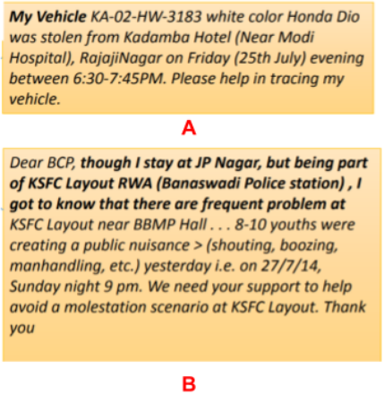  
  
Select the correct labels for A and B :

 A = Direct Communication ; B = Indirect Communication

 A = Indirect Communication ; B = Indirect Communication

 A = Direct Communication ; B = Direct Communication

 A = Indirect Communication ; B = Direct Communication

### No, the answer is incorrect. Score: 0

### Accepted Answers:

*A = Direct Communication ; B = Indirect Communication*

Assignment 6

You receive an email from “Facebook Technical Support” from an unverified email, not related to Facebook.com, asking you to reset your password via a suspicious form. This is called \_\_\_\_\_\_.

 Phishing

 Clickbaiting

 Compromised Account

 None of the above

### Yes, the answer is correct. Score: 1

### Accepted Answers:

*Phishing*

**1 point**

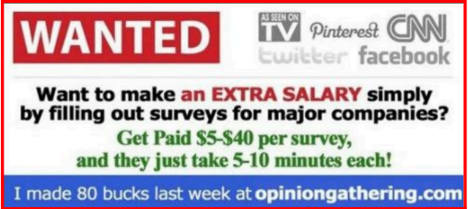  
  
While browsing a social media website, you come across the post shown above. According to the lecture, the post falls under :

 Work From Home Scam

 Hashtag Hijacking

 Compromised Account

 None of the above

### Yes, the answer is correct. Score: 1

### Accepted Answers:

*Work From Home Scam*

**1 point**

A group of hackers decide to target the Managing Director of a Company with the intention of stealing his/her credit card details by sending suspicious emails. As discussed in the lecture,this is called \_\_\_\_\_\_ .

 Clickbaiting

 Whaling

 Account Compromise

 None of the above

### Yes, the answer is correct. Score: 1

### Accepted Answers:

*Whaling*

**1 point**

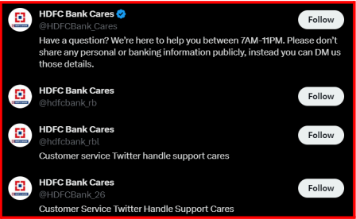  
  
The above image is an example of \_\_\_\_\_\_ .

 Hashtag Hijacking

 Compromised Account

 Fake Customer Service Accounts

 None of the above

### Yes, the answer is correct. Score: 1

### Accepted Answers:

*Fake Customer Service Accounts*

**1 point**

As discussed in the lecture, which of the following helps in improving the Pagerank of a website (say, abc.com) on search engines ?

 Reputed websites creating reciprocal links with abc.com

 abc.com creating unidirectional links to many websites

 Number of links on abc.com’s homepage

 None of the above

### Yes, the answer is correct. Score: 1

### Accepted Answers:

*Reputed websites creating reciprocal links with abc.com*

**1 point**

Spamming the index of search engines is called

 Spamdexing

 Spamexing

 Spamming

 None of the above

### Partially Correct. Score: 0.5

### Accepted Answers:

*Spamdexing*

*Spamexing*

**1 point**

Abhishek and Suresh are college batchmates. Abhishek sees Suresh’s profile on Instagram and follows him. Suresh after seeing this notification, feels compelled to follow back Abhishek. This phenomenon is called \_\_\_\_\_\_ .

 Spamming

 Reciprocity

 Link farming

 All of the above

### Yes, the answer is correct. Score: 1

### Accepted Answers:

*Reciprocity*

**1 point**

Consider three accounts on Twitter:  
  
Anushka with 500 followers and 250 following  
Ramesh with 1,500 followers and 1,000 following  
Himanshu with 500 followers and 200 following  
  
Consider, all of them tweeted about #BLRrains expressing their happiness experiencing rain.  
  
According to the lecture, consider the indegree of these accounts and select which of the following accounts are likely to rank higher while searching for #BLRrains on Twitter.

 Anushka

 Ramesh

 Himanshu

### Yes, the answer is correct. Score: 1

### Accepted Answers:

*Ramesh*

**1 point**

Which of the following is/are the most widely used formats to represent node-edge graphs on computers ?

 Adjacency Matrix

 CSV

 GraphML

 None of the above

### Partially Correct. Score: 0.67

### Accepted Answers:

*Adjacency Matrix*

*CSV*

*GraphML*

**1 point**

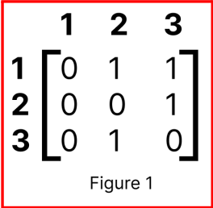  
  
The above adjacency matrix (Figure 1) is an example of \_\_\_\_\_\_\_

 Directed Graph

 Undirected Graph

### Yes, the answer is correct. Score: 1

### Accepted Answers:

*Directed Graph*

**1 point**

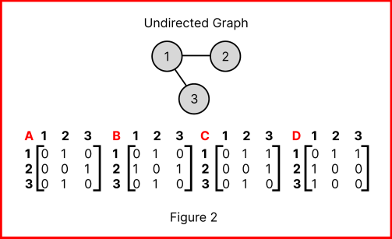  
  
Consider the above image (Figure 2), and select the correct adjacency matrix representation of the above shown undirected graph.

 A

 B

 C

 D

### No, the answer is incorrect. Score: 0

### Accepted Answers:

*D*

**1 point**

An NxN adjacency matrix implies there are \_\_\_\_\_\_ nodes in the graph.

 N/2

 N-1

 2N-1

 None of the above

### Yes, the answer is correct. Score: 1

### Accepted Answers:

*None of the above*

**1 point**

Observe the graph below (Figure 3).  
          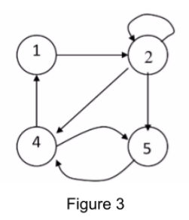  
  
The indegree of Node 2 is \_\_\_\_\_\_\_\_ .

 1

 2

 3

 4

### Yes, the answer is correct. Score: 1

### Accepted Answers:

*2*

**1 point**

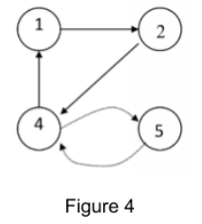  
  
Consider each node to be an account on Instagram in the graph above (Figure 4). Which of the above nodes is/are the most influential ?

 Node 1

 Node 2

 Node 4

 Node 5

### No, the answer is incorrect. Score: 0

### Accepted Answers:

*Node 4*

**1 point**

Which of the following is/are graph centrality measures?

 Node degree

 Betweenness centrality

 Closeness centrality

 None of the above

### Yes, the answer is correct. Score: 1

### Accepted Answers:

*Node degree*

*Betweenness centrality*

*Closeness centrality*

Assignment 7

According to the study discussed in the lecture, which of the following users were most likely to reciprocate links from spammers ?

 Users with less than 100 followers

 Users with less than 1,000 followers

 Users with more than 10,000 followers

 None of the above

### No, the answer is incorrect. Score: 0

### Accepted Answers:

*Users with more than 10,000 followers*

**1 point**

According to the study discussed in the lecture, which of the following users usually engaged themselves in Link Farming ?

 People talking about Business, Internet Marketing, Money etc.

 People promoting their own business or content or trends in a domain.

 Equally distributed among Random Samples of users all across Twitter.

 None of the above

### Yes, the answer is correct. Score: 1

### Accepted Answers:

*People talking about Business, Internet Marketing, Money etc.*

*People promoting their own business or content or trends in a domain.*

**1 point**

The above image from Gmail is an example of the ideas proposed by Facemail from MIT.  
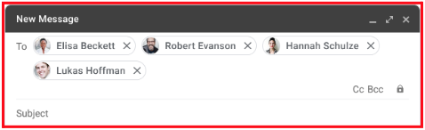

 True

 False

### Yes, the answer is correct. Score: 1

### Accepted Answers:

*True*

**Observe the image below and answer the following questions [4-5] :**  
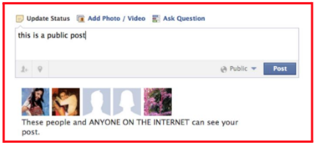

**1 point**

Which of the following nudge has been shown in the picture above ?

 Sentiment Nudge

 Timer Nudge

 Picture Nudge

 None of the above

### No, the answer is incorrect. Score: 0

### Accepted Answers:

*Picture Nudge*

**1 point**

Select the utility of the above type of nudge :

 Making sure that you are sharing content with the intended audience/people.

 Giving you the opportunity to cancel your post during a certain timeframe.

 Making sure your posts are not perceived as negative by other users.

 None of the above

### Yes, the answer is correct. Score: 1

### Accepted Answers:

*Making sure that you are sharing content with the intended audience/people.*

**1 point**

As discussed in the lecture, which of the following is/are not a social media nudge?

 Picture Nudge

 Timer Nudge

 Voice Nudge

 Video Nudge

### Yes, the answer is correct. Score: 1

### Accepted Answers:

*Voice Nudge*

*Video Nudge*

**1 point**

Which of the following statements is/are correct about nudges ?

 Interventions help users make better decisions about posting on social media.

 The primary aim of nudges is to reduce user generated content on social media.

 Nudges help individuals avoid regrettable online disclosures.

 All of the above

### Yes, the answer is correct. Score: 1

### Accepted Answers:

*Interventions help users make better decisions about posting on social media.*

*Nudges help individuals avoid regrettable online disclosures.*

**1 point**

Hemant wanted to steal data from a rival business by going to their office and transferring the required files by connecting a USB Flash Drive to the target computer. This type of attack is called \_\_\_\_\_\_\_\_.

 Physical Attack

 Semantic Attack

 Syntactic Attack

 All of the above

### Yes, the answer is correct. Score: 1

### Accepted Answers:

*Physical Attack*

**1 point**

Denial of Service Attacks and Buffer Overflow Attacks fall under :

 Physical Attacks

 Semantic Attacks

 Syntactic Attacks

 None of the above

### Yes, the answer is correct. Score: 1

### Accepted Answers:

*Syntactic Attacks*

**1 point**

Shivani, in order to steal login credentials from Anisha, sends an email to her with the subject “Check your NPTEL Certification Exam Results Here !” which directs Anisha towards a login form with a website domain not associated with NPTEL. This is a type of \_\_\_\_\_\_\_ attack.

 Syntactic

 Semantic

 Physical

 None of the above

### Yes, the answer is correct. Score: 1

### Accepted Answers:

*Semantic*

**1 point**

Himesh, a college student, gets a malicious SMS from an unidentified source saying “Your Bank Account has been suspended : Click here to re-activate your account”. This example most closely resembles :

 Whaling

 Vishing

 Smsishing

 None of the above

### Yes, the answer is correct. Score: 1

### Accepted Answers:

*Smsishing*

**1 point**

Consider the following code snippet :  
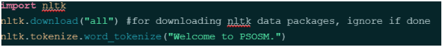

What is the output from line 3 (word\_tokenize function) above ?

 ['W', 'e', 'l', 'c', 'o', 'm', 'e', ' ', 't', 'o', ' ', 'P', 'S', 'O', 'S', 'M', '.']

 ['Welcome', 'to', 'PSOSM', '.']

 ['Welcome', 'to', 'PSOSM']

 None of the above

### No, the answer is incorrect. Score: 0

### Accepted Answers:

*['Welcome', 'to', 'PSOSM', '.']*

**1 point**

Consider the following list of words generated using nltk

[our, are, yourself, yourselves, apple, orange, have, doesn’t, aren't, out, most, where]

Which of the following are not stop words ?

 apple

 orange

 yourself

 most

### Yes, the answer is correct. Score: 1

### Accepted Answers:

*apple*

*orange*

**1 point**

Consider the below code snippet, consider the variable token holds 1000+ words extracted from a text corpus.  
IMG_259

What is the purpose of the translate function as shown above ?

 To map uppercase characters to lowercase characters in the tokens list

 To map all punctuations to a null character in the tokens list

 To map all null characters to punctuations in the tokens list

 None of the above

### Yes, the answer is correct. Score: 1

### Accepted Answers:

*To map all punctuations to a null character in the tokens list*

**1 point**

Which of the following code snippets can be used to count the number of words in a list named tokens with 1000+ elements(words).

L = {}

for i in tokens:

    if i not in L:

        L[i] = 1

    else:

        L[i] += 1

print(l)

from collections import Counter

print(Counter(tokens))

 Counter(tokens).count()

 None of the above

### Partially Correct. Score: 0.5

### Accepted Answers:

*L = {}*

*for i in tokens:*

*if i not in L:*

*L[i] = 1*

*else:*

*L[i] += 1*

*print(l)*

*from collections import Counter*

*print(Counter(tokens))*

Assignment 8

Which of the following refers to profile linking on social media as discussed in the lectures ?

 The ability to connect profiles of a user on different social networks.

 Posting on multiple social media from a single platform.

 A common verification check mark across two or more social networks.

 None of the above

### Yes, the answer is correct. Score: 1

### Accepted Answers:

*The ability to connect profiles of a user on different social networks.*

**1 point**

Which of the following OSNs contain quality and descriptive information for the purposes of profile linking, as discussed in the lecture ?

 4Chan

 Reddit

 Whisper

 LinkedIn

### Yes, the answer is correct. Score: 1

### Accepted Answers:

*LinkedIn*

**1 point**

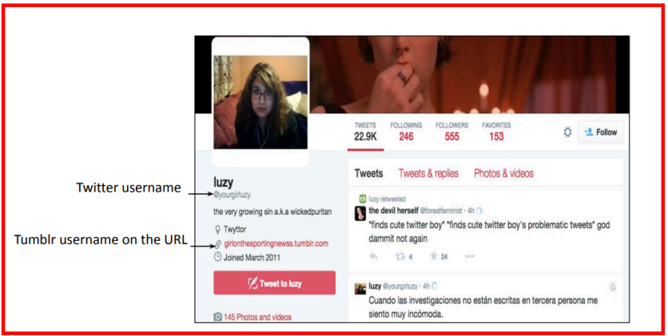  
The above X(formerly Twitter) profile helps in profile linking through self-identification.

 True

 False

### Yes, the answer is correct. Score: 1

### Accepted Answers:

*True*

**1 point**

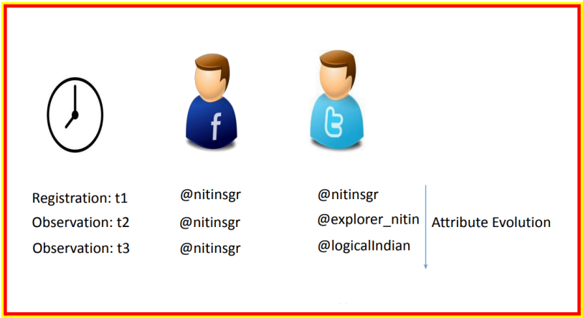  
Select the correct observations for the above image.

 The above image is a representation of username changes across Facebook and Twitter over time

 As time passes, similarity between usernames across Facebook and Twitter decreases.

 As time passes, similarity between usernames across Facebook and Twitter increases.

 None of the above

### Partially Correct. Score: 0.5

### Accepted Answers:

*The above image is a representation of username changes across Facebook and Twitter over time*

*As time passes, similarity between usernames across Facebook and Twitter decreases.*

**1 point**

Which of the following feature(s) can be used for profile linking on social media. Say, between Facebook and X(formerly Twitter) for a boy called Arjun ?

 Profile Picture

 Username

 Similarity between people followed by the Arjun on both platforms

 Similarity between people who follow Arjun on both platforms

### Yes, the answer is correct. Score: 1

### Accepted Answers:

*Profile Picture*

*Username*

*Similarity between people followed by the Arjun on both platforms*

*Similarity between people who follow Arjun on both platforms*

**1 point**

Why is studying username change behavior is/are preferable for social media researchers?

 This is one of the unique attributes of the user

 It is usually restricted in character length, allowing for smaller datasets

 It is the publicly available attribute

 None of the above

### Partially Correct. Score: 0.33

### Accepted Answers:

*This is one of the unique attributes of the user*

*It is usually restricted in character length, allowing for smaller datasets*

*It is the publicly available attribute*

**1 point**

Which of the following is/are the reason(s) behind using anonymous social networks ?

 Increasing awareness of privacy amongst social media users

 Preventing use of personal information available publicly for surveillance purposes

 Avoiding consequences of controversial political opinions posted on social media

 None of the above

### Yes, the answer is correct. Score: 1

### Accepted Answers:

*Increasing awareness of privacy amongst social media users*

*Preventing use of personal information available publicly for surveillance purposes*

*Avoiding consequences of controversial political opinions posted on social media*

**1 point**

Which of the following is/are anonymous social networks?

 Whisper

 Yik Yak

 Blind

 None of the above

### Yes, the answer is correct. Score: 1

### Accepted Answers:

*Whisper*

*Yik Yak*

*Blind*

**1 point**

“Whispers” on Whisper are equivalent to \_\_\_\_\_\_\_ on X (formerly Twitter)

 Replies

 Likes

 Tweets

 None of the above

### Yes, the answer is correct. Score: 1

### Accepted Answers:

*Tweets*

**1 point**

Observe the graph below regarding replies on Whisper and answer the question below.  
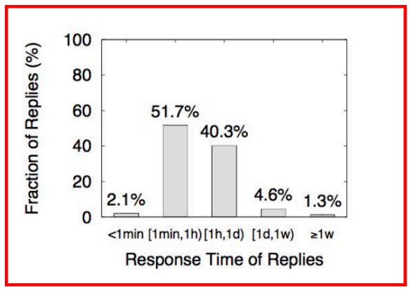  
  
“If a whisper does not get attention shortly after posting, it is unlikely to get attention later.” This statement is :

 True

 False

### Yes, the answer is correct. Score: 1

### Accepted Answers:

*True*

Observe the table given below and answer the following questions [11-13]  
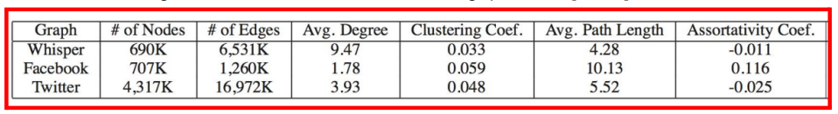

**1 point**

For the same number of Nodes/Users on Whisper, Facebook and Twitter, users on Whisper create more connections/edges than on Facebook/Twitter.

 True

 False

### Yes, the answer is correct. Score: 1

### Accepted Answers:

*True*

**1 point**

Users on Whisper tend to create more close-knit groups than on Facebook/Twitter.

 True

 False

### Yes, the answer is correct. Score: 1

### Accepted Answers:

*False*

**1 point**

Assortativity Coefficient being closer to zero implies the graph is more random than “small world”

 True

 False

### Yes, the answer is correct. Score: 1

### Accepted Answers:

*True*

**1 point**

The measure of how close a graph is to complete, with 0 indicating an incomplete and 1 indicating a complete graph is called \_\_\_\_\_\_\_\_\_.

 Average Degree

 Clustering Coefficient

 Graph Density

 None of the above

### Yes, the answer is correct. Score: 1

### Accepted Answers:

*Graph Density*

**1 point**

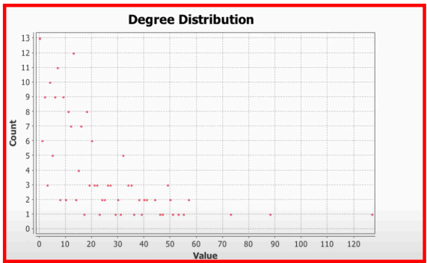  
Consider the above Degree Distribution graph generated in Gephi. Which of the following statements is/are correct about this ?

 The average degree of the graph is greater than 70

 The average degree of the graph is lesser than 50

 The average degree of the graph is 125

 The average degree of the graph is less than 10

### No, the answer is incorrect. Score: 0

### Accepted Answers:

*The average degree of the graph is lesser than 50*

Assignment 9

Which of the following is/are location-based services?

 Foursquare

 Ola

 Yelp

 Uber

### Yes, the answer is correct. Score: 1

### Accepted Answers:

*Foursquare*

*Ola*

*Yelp*

*Uber*

**1 point**

Mayorships on Foursquare are given to:

 The first person to check in at a location

 The person who leaves the most tips at a location

 The person who checks in most frequently at a location in a given period

 People who write the most reviews on a location

### Yes, the answer is correct. Score: 1

### Accepted Answers:

*The person who checks in most frequently at a location in a given period*

**1 point**

Which of the following is publicly available data on Foursquare?

 Mayorships

 Tips

 Dones

 Checkins

### Partially Correct. Score: 0.66

### Accepted Answers:

*Mayorships*

*Tips*

*Dones*

**1 point**

Look at the figure (Figure 1) given below for the Cumulative Distribution of the Number of Mayorships, Tips and Dones per User:  
             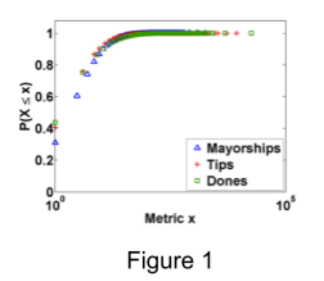  
  
Majority of the users on Foursquare do not contribute to the Mayorships, Tips or Dones. This statement is :

 True

 False

### Yes, the answer is correct. Score: 1

### Accepted Answers:

*True*

**1 point**

In the paper as discussed in the lecture, a high correlation between the number of mayorships and the number of tips across cities, with a Spearman’s correlation coefficient ρρ equal to 0.78 indicates that :

 There is a high monotone increasing relation between the number of mayorships and the number of tips.

 There is a high monotone decreasing relation between the number of mayorships and the number of tips.

 There is no relation regarding monotonicity between the number of mayorships and the number of tips.

 None of the above.

### Yes, the answer is correct. Score: 1

### Accepted Answers:

*There is a high monotone increasing relation between the number of mayorships and the number of tips.*

**1 point**

Look at the figure (Figure 2) given below for the Cumulative Distribution of Displacements Between Consecutive Tips/Dones Posted per User:  
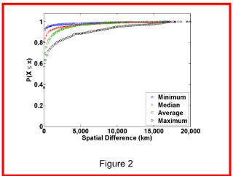  
About \_\_\_\_\_% of the users have spatial differences between their tips/dones at more than or equal to 6,000km on average.

 10

 20

 30

 40

### Yes, the answer is correct. Score: 1

### Accepted Answers:

*10*

**1 point**

Look at the (Figure 3) for the Cumulative Distribution of Time Interval Between Consecutive Tips/Dones Posted per User :  
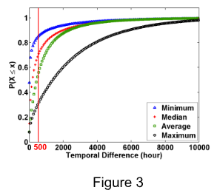  
50% of the users post tips/dones in intervals of less than 500 hours on average. This statement is :

 True

 False

### Yes, the answer is correct. Score: 1

### Accepted Answers:

*True*

**1 point**

What is the difference between Pearson and Spearman rank correlation?  
Hint: [https://en.wikipedia.org/wiki/Pearson\_correlation\_coefficient](https://en.wikipedia.org/wiki/Pearson_correlation_coefficient" \o "" \t "/Users/hamzakhan/Downloads/x/_blank)

 Pearson correlation assesses linear relationships, while Spearman correlation evaluates monotonic relationships.

 Spearman correlation is always between -1 and 1, while Pearson correlation can have values outside this range.

 Spearman correlation is calculated using a formula involving the sum of squared differences, whereas Pearson correlation is based on the product of z-scores.

 All of the above

### Yes, the answer is correct. Score: 1

### Accepted Answers:

*Pearson correlation assesses linear relationships, while Spearman correlation evaluates monotonic relationships.*

**1 point**

Which plot is shown in the below figure (Figure 4) ?  
         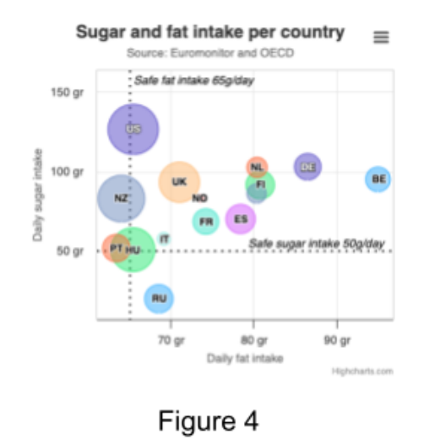

 Scatter Plot

 Bar Chart

 Bubble Plot

 Histogram

### Yes, the answer is correct. Score: 1

### Accepted Answers:

*Bubble Plot*

**1 point**

Which of the following charts can be generated using highcharts ?

 Bar Chart

 Line Chart

 Scatter Plot

 Bubble Chart

### Yes, the answer is correct. Score: 1

### Accepted Answers:

*Bar Chart*

*Line Chart*

*Scatter Plot*

*Bubble Chart*

**Common Information for Q11-14:**  
  
*To import highcharts into Python version >=3.10 use the following code:*  
  
*// Fix for python version >= 3.10*  
import collections.abc  
collections.Iterable = collections.abc.Iterable  
collections.Mapping = collections.abc.Mapping  
collections.MutableSet = collections.abc.MutableSet  
collections.MutableMapping = collections.abc.MutableMapping  
// then import highcharts  
from highcharts import Highchart

**1 point**

Which of the following is the correct **chart type** in the options dictionary to print a horizontal bar chart ?

 bar

 column

 horizontal\_bar

 None of the above

### No, the answer is incorrect. Score: 0

### Accepted Answers:

*bar*

**1 point**

Refer to the options dictionary for a line chart as shown in Figure 5 and complete the code with the correct option for enabling the legend  
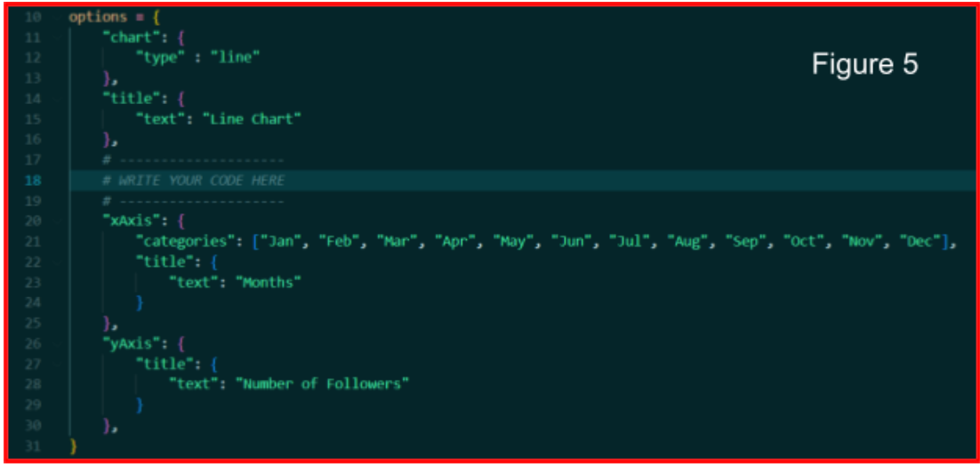

 "legend": {'enabled': True},

 "legend": True,

 "legend": {‘legend’: True},

 None of the above

### Yes, the answer is correct. Score: 1

### Accepted Answers:

*"legend": {'enabled': True},*

**1 point**

Ravi wanted to plot his number of followers on Instagram for 2023 in a line chart using Highcharts. When he ran the code given below, it gave an unexpected output as shown below in (Figure 6) :  
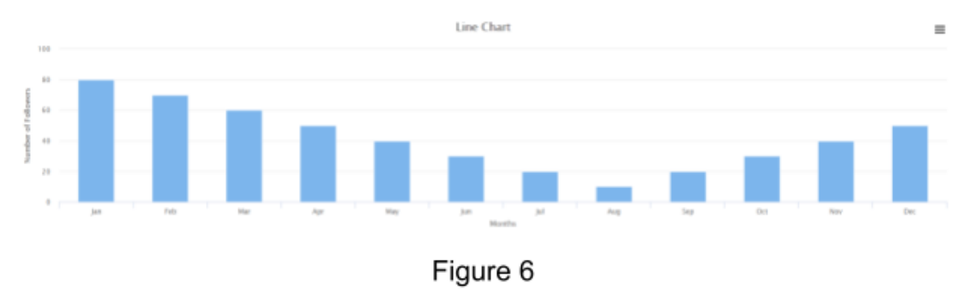  
Study the code below (Figure 7) and determine the line due to which he might be getting the unexpected output (assume all necessary imports have already been made) :  
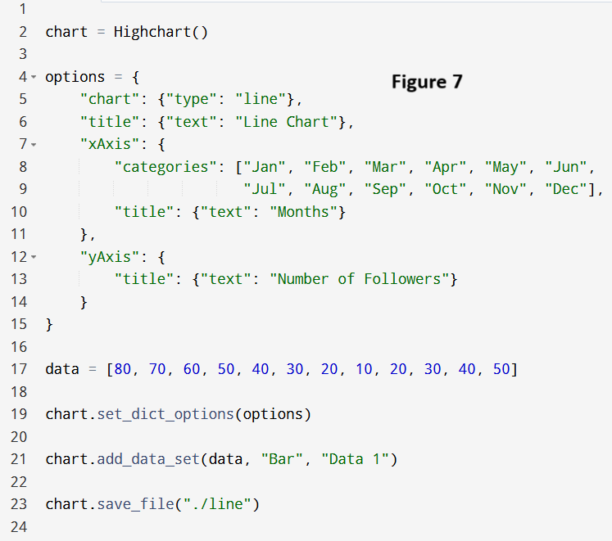

 Line 6

 Line 17

 Line 19

 Line 21

### Yes, the answer is correct. Score: 1

### Accepted Answers:

*Line 21*

**1 point**

Which of the following is the correct syntax for labeling the legend for some given data in a scatter plot using Highcharts ?

 chart.add\_data\_set(data1, 'scatter', name = 'label\_name')

 chart.add\_data\_set(data1, 'scatter', 'label\_name')

 chart.add\_data\_set(data1, 'scatter', label = 'label\_name')

 None of the above

### Partially Correct. Score: 0.5

### Accepted Answers:

*chart.add\_data\_set(data1, 'scatter', name = 'label\_name')*

*chart.add\_data\_set(data1, 'scatter', 'label\_name')*

Assignment 10

Which of the following social networks was NOT mentioned in the paper as a source for the dataset ?

 Twitter

 Foursquare

 Facebook

 Google Plus

### No, the answer is incorrect. Score: 0

### Accepted Answers:

*Facebook*

**1 point**

What is the main focus of the study mentioned in the paper ?

 Inference of Social Security Number from Home Location in Social Networks

 Inference of Home Location in Social Networks

 Impact of Nudges on Location Sharing in Social Networks

 None of the Above

### Yes, the answer is correct. Score: 1

### Accepted Answers:

*Inference of Home Location in Social Networks*

**1 point**

What is a valid AGI?

 Valid Artificial General intelligence

 Valid Ambiguous Geographical Information

 Valid Artificial Geographical Interface

 None of the above

### No, the answer is incorrect. Score: 0

### Accepted Answers:

*Valid Ambiguous Geographical Information*

**1 point**

Look at the Figure below (Figure 1) and answer the following question :  
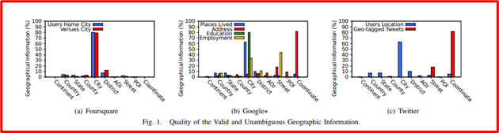  
“Majority of the users on each of the above mentioned platforms provide home location information at the street level.” This statement is:

 True

 False

### Yes, the answer is correct. Score: 1

### Accepted Answers:

*False*

**1 point**

Refer to the figure below (Figure 2) and answer the following question :  
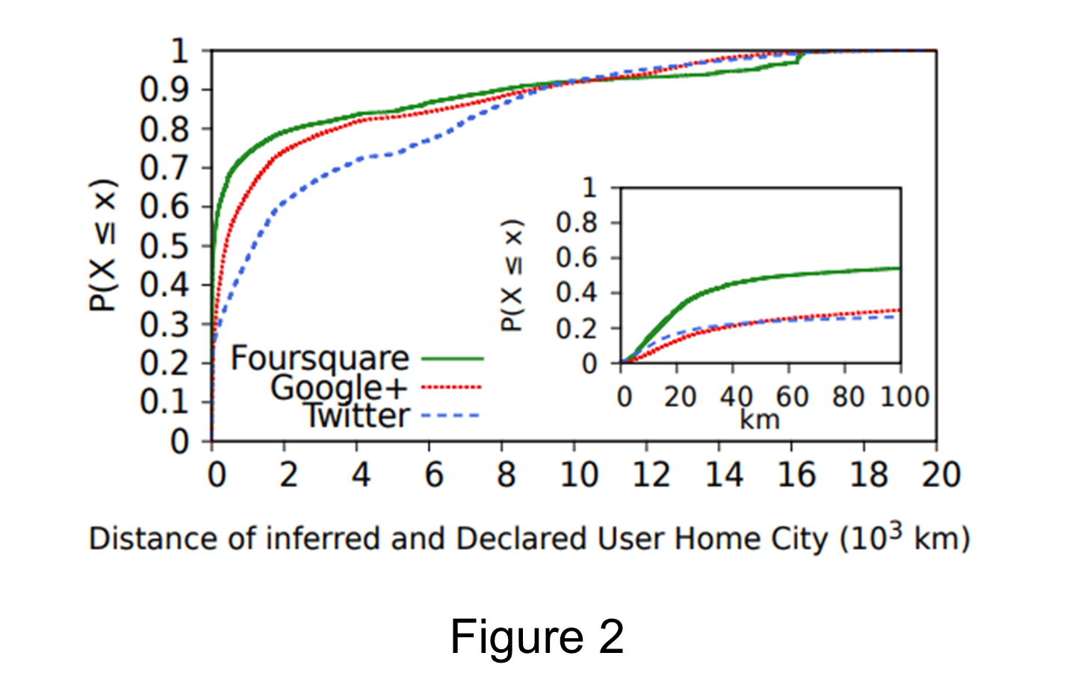  
The distance between inferred and declared user home cities on Twitter is less than 40 km for \_\_\_\_ of users.

 20 %

 40 %

 80 %

 None

### No, the answer is incorrect. Score: 0

### Accepted Answers:

*20 %*

Please go through the following paper, “On the dynamics of username change behavior on Twitter” [https://cdn.iiit.ac.in/cdn/precog.iiit.ac.in/Publications\_files/04-Jain.pdf](https://cdn.iiit.ac.in/cdn/precog.iiit.ac.in/Publications_files/04-Jain.pdf" \o "" \t "/Users/hamzakhan/Downloads/x/_blank) and answer the following questions from [Q6-Q10]

**1 point**

From the following figure (Figure 3), what is the correct inference?  
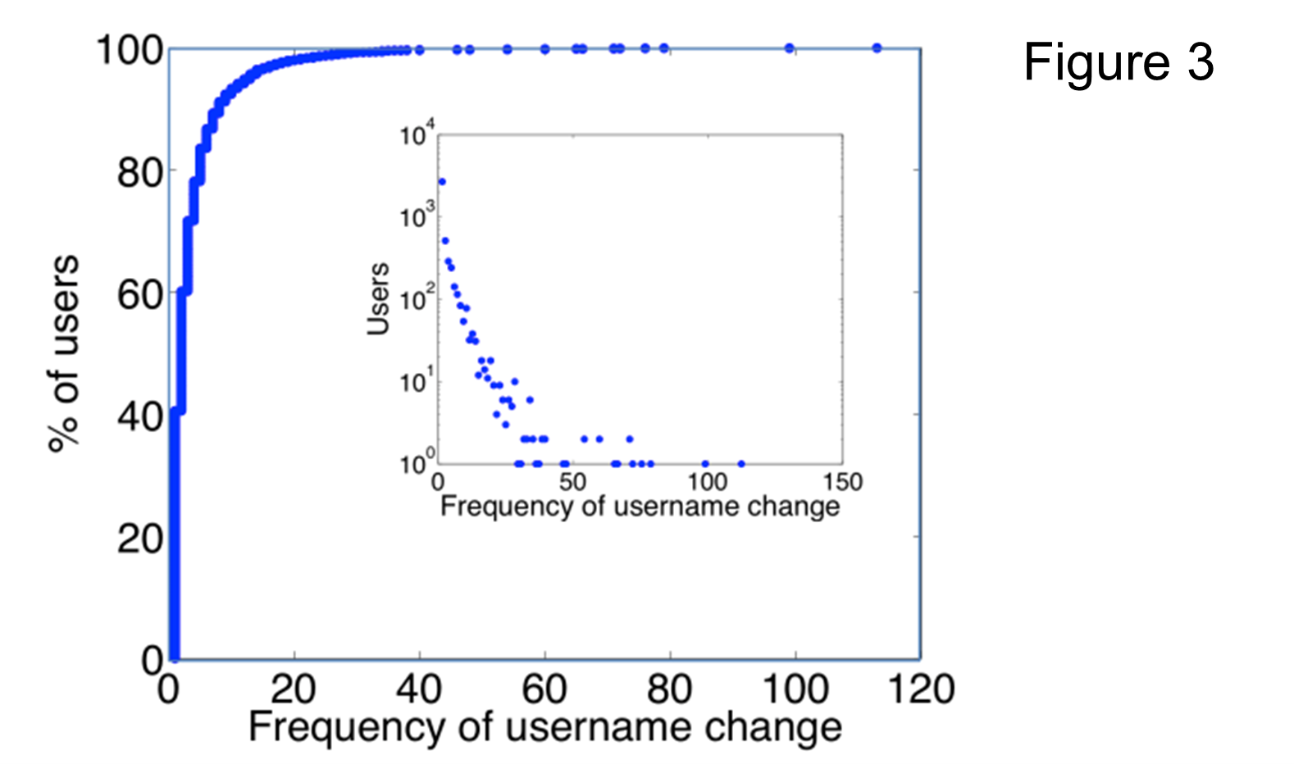

 80% of users rarely change usernames and 20% change user names frequently.

 20% of users frequently change usernames and 80% change usernames rarely.

 The percentage of users attributed to the change of usernames follows a Pareto Distribution.

 The percentage of users attributed to the change of usernames does not follow a Pareto Distribution.

### Partially Correct. Score: 0.67

### Accepted Answers:

*80% of users rarely change usernames and 20% change user names frequently.*

*20% of users frequently change usernames and 80% change usernames rarely.*

*The percentage of users attributed to the change of usernames follows a Pareto Distribution.*

**1 point**

Which of the following method(s) were used in the paper for measuring the similarity between two consecutive usernames ?

 Cosine Similarity

 Longest Common Subsequence

 Longest Common Substring

 All of the Above

### No, the answer is incorrect. Score: 0

### Accepted Answers:

*Longest Common Subsequence*

**1 point**

Observe the figure below (Figure 4) about the additions or deletions of characters to usernames of several users on Twitter while changing their usernames and select the correct option(s) :  
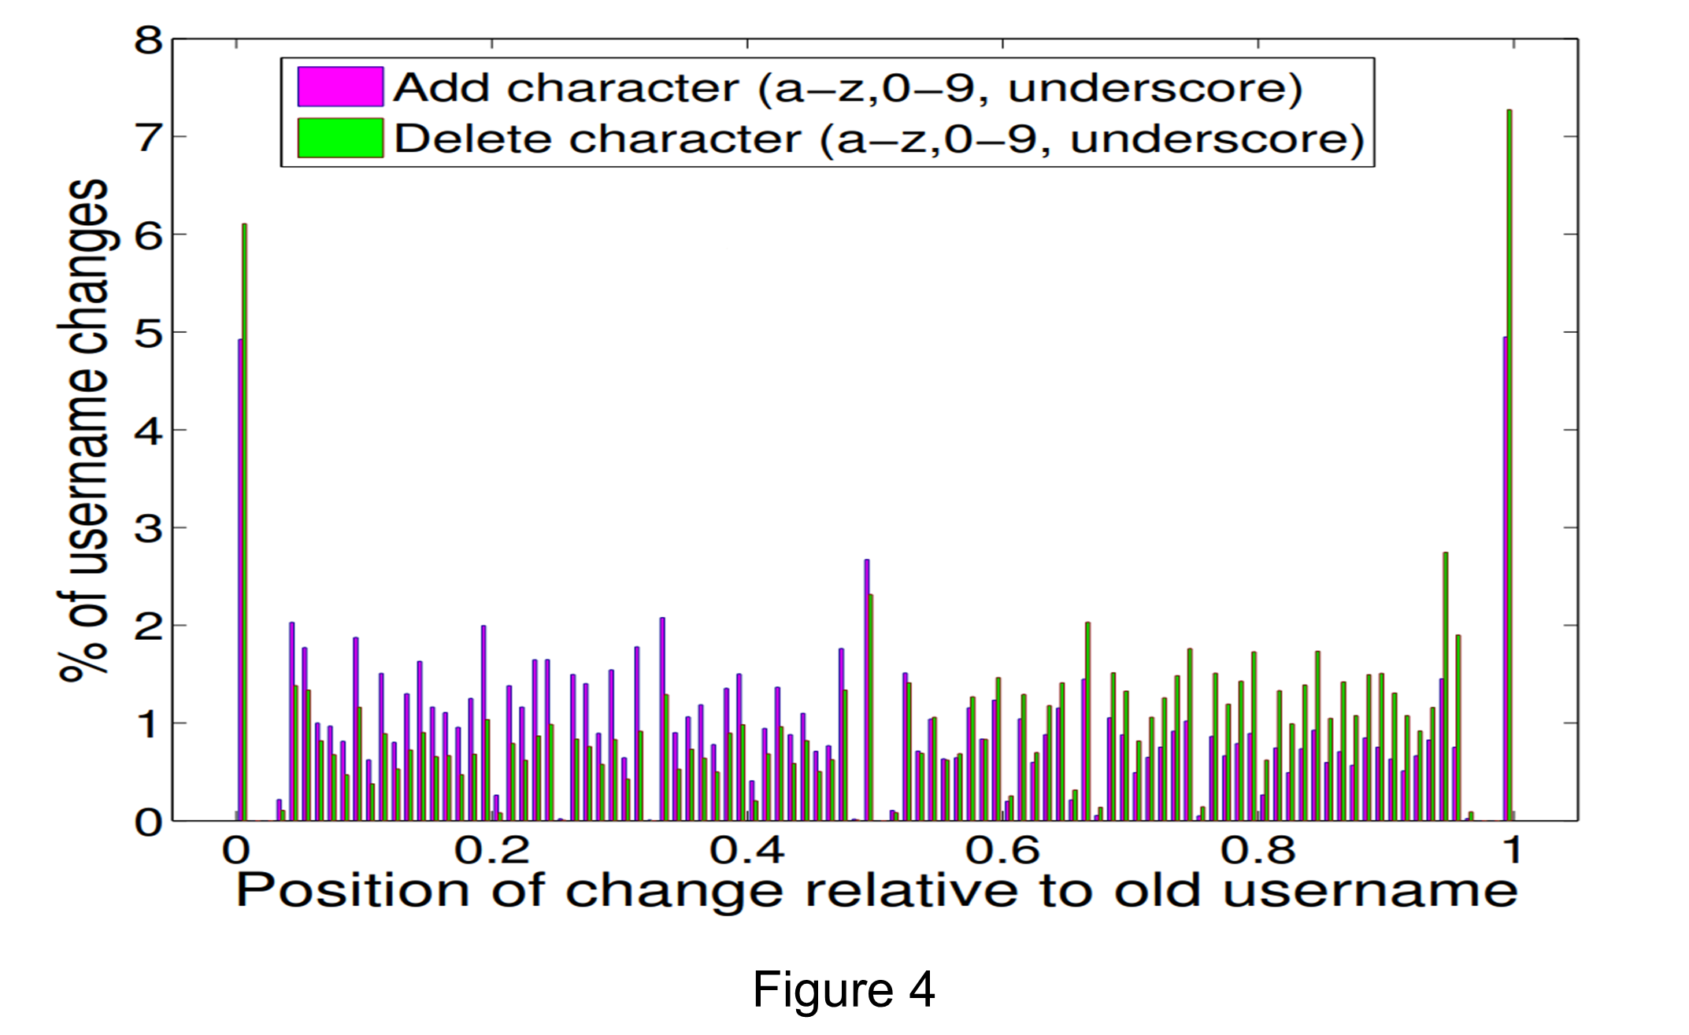

 Most users added or deleted characters either from the start or end of their username.

 Most users deleted characters at the end of their usernames.

 Most users added characters to the middle of their usernames.

 None of the Above.

### Partially Correct. Score: 0.5

### Accepted Answers:

*Most users added or deleted characters either from the start or end of their username.*

*Most users deleted characters at the end of their usernames.*

**1 point**

Which of the following statements is/are true ?

 Changing usernames rapidly in a short period of time is called Space Gain.

 Actively using common usernames like “@happy” or “@smile” is called Username Squatting.

 Inactive users preventing others from using that specific username is called Username Squatting.

 None of the above

### No, the answer is incorrect. Score: 0

### Accepted Answers:

*Inactive users preventing others from using that specific username is called Username Squatting.*

**1 point**

Refer to the figure below (Figure 5) about a partner account promoting another in a tweet and answer the following question:  
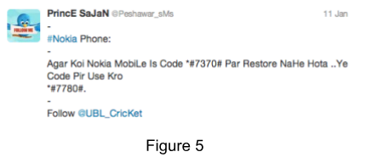  
Which of the following phenomena is shown in the above figure as discussed in the paper ?

 Username Squatting

 Obscured Username Promotion

 Adjust to Events

 Space Gain

### Yes, the answer is correct. Score: 1

### Accepted Answers:

*Obscured Username Promotion*

Please go through the following paper, “Boston Marathon Analyzing Fake Content on Twitter” [https://cdn.iiit.ac.in/cdn/precog.iiit.ac.in/Publications\_files/ecrs2013\_ag\_hl\_pk.pdf](https://cdn.iiit.ac.in/cdn/precog.iiit.ac.in/Publications_files/ecrs2013_ag_hl_pk.pdf" \o "" \t "/Users/hamzakhan/Downloads/x/_blank)and answer the following questions from [Q11-Q15]

**1 point**

Which of the following statements is true about Boston blasts?

 Twin blasts occurred during the Boston Marathon on April 15th, 2013 at 18:50 GMT

 Twin blasts occurred during the Boston Marathon on April 15th, 2009 at 18:50 GMT

 Four people were killed and 264 were injured in the incident

 All of the above

### Yes, the answer is correct. Score: 1

### Accepted Answers:

*Twin blasts occurred during the Boston Marathon on April 15th, 2013 at 18:50 GMT*

**1 point**

What does the following figure depict (Figure 6) ?  
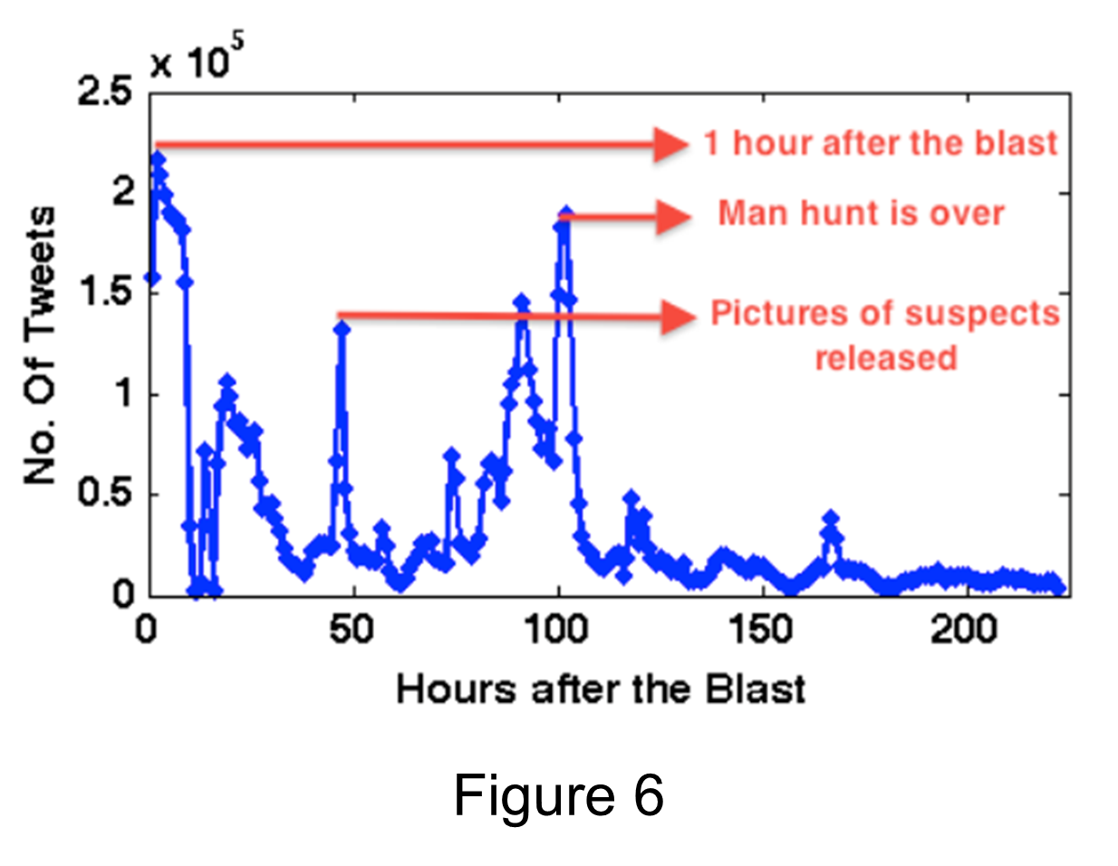

 The figure shows the temporal distribution of tweets after the Boston blast

 The figure shows the spatial distribution of tweets after the Boston blast

 Both (a) and (b)

 None of the above

### Yes, the answer is correct. Score: 1

### Accepted Answers:

*The figure shows the temporal distribution of tweets after the Boston blast*

Refer to the table below (Table 1) about some parameters of Aditya’s account and answer the following questions [Q13-15]  
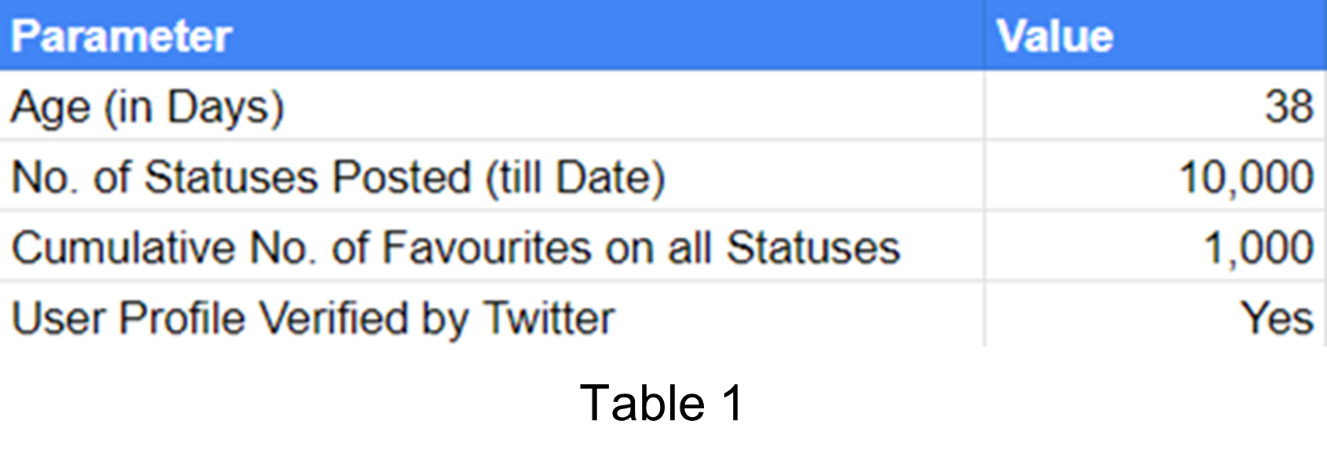

**1 point**

Calculate the GlobalEngagement for Aditya.  
Hint: IMG_263 please refer to the n(status) and age definitions as provided in the paper. The age is to be taken in hours.

 263.15

 10.96

 1.096

 None of the above

### No, the answer is incorrect. Score: 0

### Accepted Answers:

*10.96*

**1 point**

Calculate the Likeability for Aditya.  
Hint: IMG_264, please refer to the n(favourited) and n(status) definitions as provided in the paper.

 0.1

 0.05

 10

 None of the above

### Yes, the answer is correct. Score: 1

### Accepted Answers:

*0.1*

**1 point**

“The credibility of a verified user according to the method in the paper will be considered as 1”. This statement is:

 True

 False

### Yes, the answer is correct. Score: 1

### Accepted Answers:

*True*

Assignment 11

Which of the following can be used for writing Python Programs in an Ubuntu Terminal ?

 vim

 neovim

 vi

 All of the Above

### Yes, the answer is correct. Score: 1

### Accepted Answers:

*All of the Above*

**1 point**

What is used to install and manage packages for Python?

 pip

 npm

 apt get

 Anaconda

### Yes, the answer is correct. Score: 1

### Accepted Answers:

*pip*

**1 point**

Why is a "Graph" API called so?

 It allows users to draw and create graphs and charts

 It represents social connections and relationships as a graph data structure

 It primarily deals with geographical mapping and location-based services

 It is used exclusively for graph theory and mathematical computations

### Yes, the answer is correct. Score: 1

### Accepted Answers:

*It represents social connections and relationships as a graph data structure*

**1 point**

What characteristics did the researchers find among top link farmers?

 They had low in-degree compared to random samples

 They were unpopular and inactive users

 They had high in-degree compared to random samples

 None of the Above

### Yes, the answer is correct. Score: 1

### Accepted Answers:

*They had high in-degree compared to random samples*

**1 point**

Which of the following are/were virtual worlds in Social Media ?

 Club Penguin

 Habbo

 Twitter

 All of the above

### Yes, the answer is correct. Score: 1

### Accepted Answers:

*Club Penguin*

*Habbo*

**1 point**

Which V of social media represents “Amount of content generated across social media platforms.”

 Value

 Velocity

 Volume

 Veracity

### Yes, the answer is correct. Score: 1

### Accepted Answers:

*Volume*

**1 point**

Which of the following is/are e-crimes on online social media ?

 Phishing

 Clickbaiting

 Work From Home Scam

 All of the Above

### Yes, the answer is correct. Score: 1

### Accepted Answers:

*All of the Above*

**1 point**

Which of the following is/are the goals of a phishing attack ?

 Stealing personal information

 Stealing your financial information

 Stealing your identity

 Attacking your social networking contacts

### Yes, the answer is correct. Score: 1

### Accepted Answers:

*Stealing personal information*

*Stealing your financial information*

*Stealing your identity*

*Attacking your social networking contacts*

**1 point**

Hitesh has 400 followers on Twitter, 500 followers on Facebook and 1400 followers on Instagram. The act of finding the actual number of unique followers across all his social media profiles is called de-duplicating. This statement is:

 True

 False

### Yes, the answer is correct. Score: 1

### Accepted Answers:

*True*

**1 point**

A node in a graph has an in-degree of 2 and an out-degree of 4. The degree of this node is:

 2

 4

 6

 8

### Yes, the answer is correct. Score: 1

### Accepted Answers:

*6*

**1 point**

Which of the following is the correct command for initializing a git repository in a newly created empty folder ?

 git initialize

 git create

 git initiate

 git init

### Yes, the answer is correct. Score: 1

### Accepted Answers:

*git init*

**1 point**

Latanya Sweeney's research highlighted how two seemingly unrelated pieces of information can be linked to reidentify an individual. Which term best describes this concept?

 Data Anonymization

 Data Aggregation

 Reidentification

 All of the above

### Yes, the answer is correct. Score: 1

### Accepted Answers:

*Reidentification*

**1 point**

Which of the following OSNs have an API ?

 X (formerly Twitter)

 Facebook

 YouTube

 None of the above

### Yes, the answer is correct. Score: 1

### Accepted Answers:

*X (formerly Twitter)*

*Facebook*

*YouTube*

**1 point**

Which of the following are not stopwords in the following list?  
  
stopwords = ["i", "me", "my", "myself", "we", "our", "ours", "ourselves", "you", "your", "yours", "yourself", "yourselves", "he", "him", "his", "himself", "she", "her", "hers", "herself", "it", "its", "had", "having", "do", "does", "did", "doing", “mango”, "a", "an", "the", "and", "but", "if", "or", "because", "as", "until", "while", "of", "at", "by", "for", "with", "about", "against", "between", "into",”now"]

 because, against, mango, yourself

 mango, now

 mango

 All the words in the list are stopwords

### No, the answer is incorrect. Score: 0

### Accepted Answers:

*mango*

**1 point**

A sentiment analysis study analyzes a text passage for valence and arousal values. On a scale of -1 to 1, the valence and arousal score is 0.80 and 0.90. What do these values suggest about the emotional characteristics of the text?

 Negative sentiment, low emotional intensity

 Positive sentiment, High emotional intensity

 Negative sentiment, high emotional intensity

 Positive sentiment, low emotional intensity

### Yes, the answer is correct. Score: 1

### Accepted Answers:

*Positive sentiment, High emotional intensity*

Assignment 12